Name: Matale Peter
surname: molepo
module code: prog6212

IIE MSA
COMPUTER & INFORMATION SCIENCES

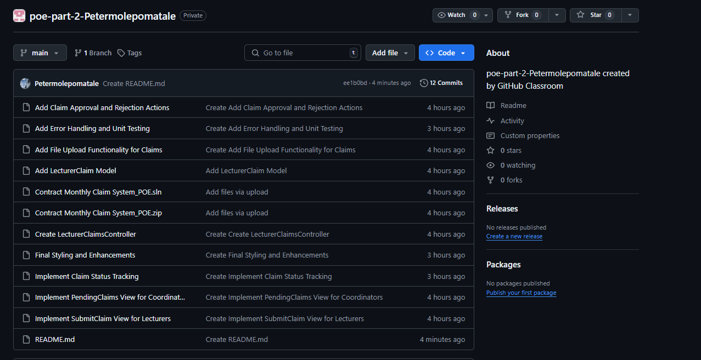
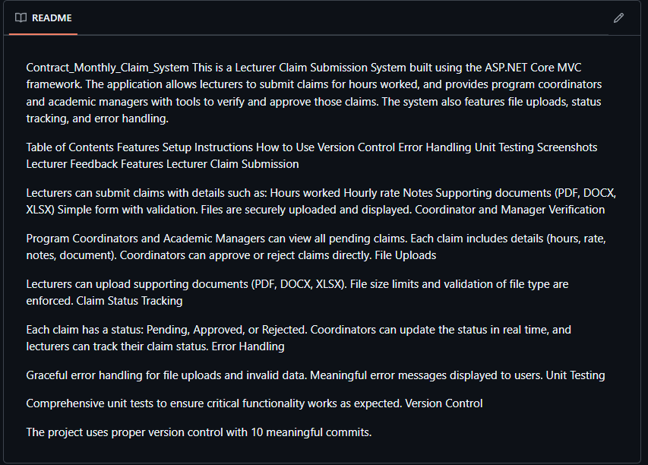

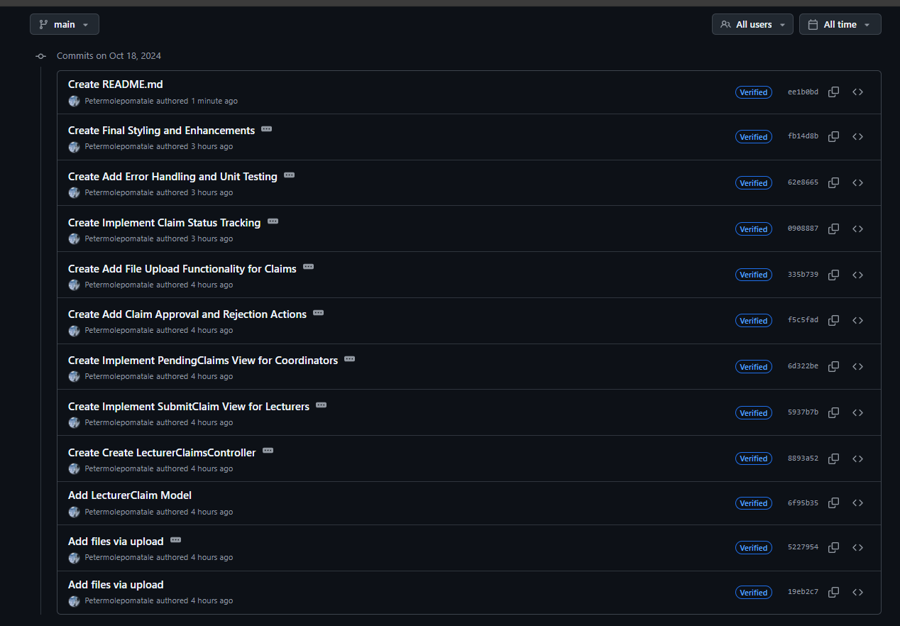
GITHUB LINK
IIEMSA/poe-part-2-Petermolepomatale: poe-part-2-Petermolepomatale created by GitHub Classroom

